**How Earth Moves**

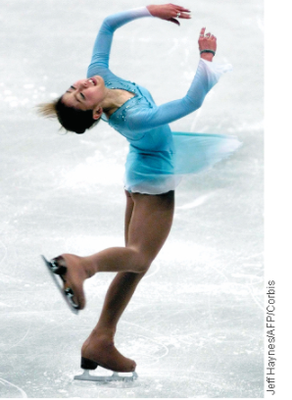Ancient astronomers studied the movements of the sun and the moon as they appeared to travel across the sky. It seemed to them as though Earth was standing still and the sun and moon were moving. Actually, the sun and moon seem to move across the sky each day because Earth is rotating on its axis. Earth also moves around the sun.**Earth moves through space in two major ways: rotation and revolution.**

**Rotation**

The imaginary line that passes through Earth’s center and the North and South poles is Earth’s **[axis](javascript:openGlossaryWnd('e_gjaxis')" \o "ALT G, Glossary Term, link opens in new window).** The spinning of Earth on its axis is called **[rotation](javascript:openGlossaryWnd('e_gjrotation')" \o "ALT G, Glossary Term, link opens in new window).**

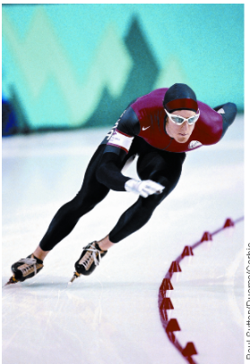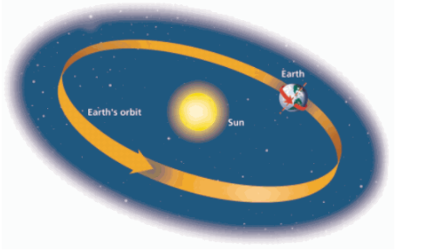Earth’s rotation causes day and night. As Earth rotates eastward, the sun appears to move westward across the sky. It is day on the side of Earth facing the sun. As Earth continues to turn to the east, the sun appears to set in the west. Sunlight can’t reach the side of Earth facing away from the sun, so it is night there. It takes Earth about 24 hours to rotate once. As you know, each 24-hour cycle of day and night is called a day.

**Figure 1: Rotation**The rotation of Earth on its axis is similar to the movement of the figure skater as she spins.

**Revolution**

In addition to rotating on its axis, Earth travels around the sun. **[Revolution](javascript:openGlossaryWnd('e_gjrevolution')" \o "ALT G, Glossary Term, link opens in new window)** is the movement of one object around another. One complete revolution of Earth around the sun is called a year. Earth follows a path, or **[orbit](javascript:openGlossaryWnd('e_gjorbit')" \o "ALT G, Glossary Term, link opens in new window),** as it revolves around the sun. Earth’s orbit is not quite circular. It is a slightly elongated circle, or ellipse.

**Figure 2: Revolution**Earth revolves around the sun just as a speed skater travels around the center of a rink during a race.

**Why the Earth Moves like it Does**

**Gravity**

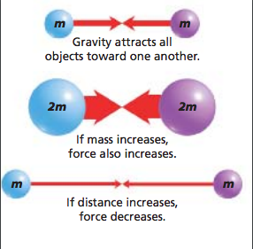Newton hypothesized that the force that pulls an apple to the ground also pulls the moon toward Earth, keeping it in orbit. This force, called **[gravity](javascript:openGlossaryWnd('e_gjgravity')" \o "ALT G, Glossary Term, link opens in new window),** attracts all objects toward each other. In Newton’s day, most scientists thought that forces on Earth were different from those elsewhere in the universe. Although Newton did not discover gravity, he was the first person to realize that gravity occurs everywhere. Newton’s **[law of universal gravitation](javascript:openGlossaryWnd('e_gjlawofunivers')" \o "ALT G, Glossary Term, link opens in new window)** states that every object in the universe attracts every other object.

The force of gravity is measured in units called newtons, named after Isaac Newton.**The strength of the force of gravity between two objects depends on two factors: the masses of the objects and the distance between them.**

**Gravitational Force and Mass**

According to the law of universal gravitation, all of the objects around you, including Earth and even this book, are pulling on you, just as you are pulling on them. Why don’t you notice a pull between you and the book? Because the strength of gravity depends in part on the masses of each of the objects. **[Mass](javascript:openGlossaryWnd('e_gjmass')" \o "ALT G, Glossary Term, link opens in new window)** is the amount of matter in an object.

**Figure 3:** [Gravity, Mass, and Distance](javascript:openPDF('view1_sx05_jart17.pdf')) The strength of the force of gravity between two objects depends on their masses and the distance between them.

Because Earth is so massive, it exerts a much greater force on you than this book does. Similarly, Earth exerts a gravitational force on the moon, large enough to keep the moon in orbit. The moon also exerts a gravitational force on Earth, which creates the tides in the oceans.

**Gravitational Force and Distance**

The strength of gravitational force is affected by the distance between two objects as well as their masses. The force of gravity decreases rapidly as distance increases. For example, if the distance between two objects were doubled, the force of gravity between them would decrease to one fourth of its original value.

**Inertia and Orbital Motion**

If the sun and Earth are constantly pulling on one another because of gravitational force, why doesn’t Earth fall into the sun? Similarly, why doesn’t the moon crash into Earth? The fact that such collisions have not occurred shows that there must be another factor at work. That factor is called inertia.

**Inertia**

The tendency of an object to resist a change in motion is **[inertia](javascript:openGlossaryWnd('e_gjinertia')" \o "ALT G, Glossary Term, link opens in new window).** You feel the effects of inertia every day. When you are riding in a car and it stops suddenly, you keep moving forward. If you didn’t have a seat belt on, your inertia could cause you to bump into the car’s windshield or the seat in front of you. The more mass an object has, the greater its inertia. An object with greater inertia is more difficult to start or stop.

Isaac Newton stated his ideas about inertia as a scientific law. **[Newton’s first law of motion](javascript:openGlossaryWnd('e_gjnewtonsfirs')" \o "ALT G, Glossary Term, link opens in new window)** says that an object at rest will stay at rest and an object in motion will stay in motion with a constant speed and direction unless acted on by a force.

**Orbital Motion**

Why do Earth and the moon remain in their orbits? **Newton concluded that two factors—inertia and gravitational force—combine to keep Earth in orbit around the sun and the moon in orbit around Earth.**

**Figure 4A:**  The Earth keeps falling around the sun because of gravity and inertia.

As shown in Figure 4A, the sun’s gravity keeps pulling the Earth toward it, preventing the Earth from moving in a straight line. At the same time, the Earth keeps moving ahead because of its inertia. If not for sun’s gravity, inertia would cause the Earth to move off through space in a straight line. In the same way, the moon revolves around the Earth because the Earth’s gravity pulls on it while the moon’s inertia keeps it moving ahead.

**Figure 4B:**  The moon keeps falling around the Earth because of gravity and inertia.

**Newton’s third law of motion.**

A single object does not have a gravitational force. This force is created between two objects. These two objects pull each other with the same gravitational force regardless of which object is thought of as pulling on the other. In other words, the force the Earth exerts on the moon is equal to the force the moon exerts on the Earth. The only difference is that the moon pulls the Earth toward the moon, while the Earth pulls the moon toward the Earth. The forces therefore in the opposite directions. This is Newton’s third law of motion. **Newton’s third law of motion** states that every force has an equal and opposite reaction force. See Figure 4A or 4B, the arrows between the planets show the equal and opposite forces of gravity. The reason that these equal forces have such different effects on the two objects is because the two objects have different amounts of mass.