Plate Boundaries Reading
Divergent Plate Boundary: Oceanic
When a divergent boundary occurs beneath oceanic lithosphere, the rising convection current below produces a mid-ocean ridge.
The Mid-Atlantic Ridge is a classic example of this type of plate boundary.

Effects that are found at a divergent boundary between oceanic plates include: mid-ocean ridges; earthquake activity; creation of new seafloor and a widening the ocean.
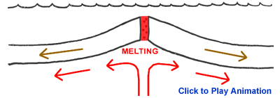
Divergent Plate Boundary: Continental
As the two plates pull apart streams and rivers will flow into the sinking rift valley to form a long linear lake. As the rift grows deeper it might drop below sea level allowing ocean waters to flow in. This will produce a narrow, shallow sea within the rift. This rift can then grow deeper and wider. If rifting continues a new ocean basin could be produced.
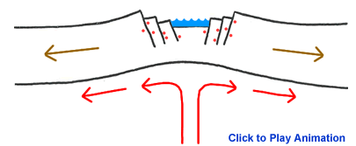
The East Africa Rift Valley is a classic example of this type of plate boundary in a very early stage of development. The plate has not been completely rifted and the valley is still above sea level. The Red Sea is an example of a more completely developed rift. There the plates have fully separated and the central rift valley has dropped below sea level.
Effects that are found at this type of plate boundary include: a rift valley, sometimes long linear lakes, earthquake activity.

Convergent Plate Boundary: Oceanic and Continental
When continental and oceanic plates collide the more-dense oceanic plate is pushed under by the less dense continental plate through a process is known as subduction. As the oceanic plate descends it partially melts and produces magma chambers. These magma chambers are less dense than the surrounding mantle materials rise through the rock. If a magma chamber rises to the surface the magma will break through in the form of a volcanic eruption.
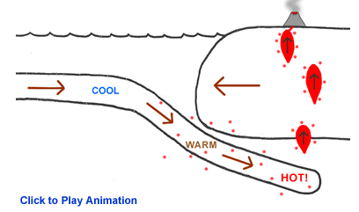
The Washington-Oregon coastline of the United States is an example of this type of convergent plate boundary. Here the Juan de Fuca oceanic plate is subducting beneath the westward moving North American continental plate. The Cascade Mountain Range is a line of volcanoes above the melting oceanic plate. The Andes Mountain Range of western South America is another example of a convergent boundary between an oceanic and continental plate. Here the Nazca Plate is subducting beneath the South American plate.
Effects of a convergent boundary between an oceanic and continental plate include earthquake activity, an ocean trench immediately off shore of the continent, a line of volcanic eruptions a few hundred miles inland from the shoreline, destruction of part of the oceanic plate.

Convergent Plate Boundary: Oceanic and Oceanic
When a convergent boundary occurs between two oceanic plates one of those plates will subduct beneath the other. The subducting plate begins to melt and magma chambers are produced and the magma rises through the rock. Magma chambers that reach the surface break through to form a volcanic eruption. In the early stages of this type of boundary the volcanoes will be deep beneath the ocean surface but later grow to be higher than sea level. This produces an island chain. With continued development the islands grow larger, merge and an elongate landmass is created.
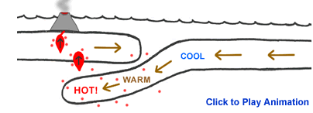
Japan, the Aleutian islands and the Eastern Caribbean islands are examples of islands formed through this type of plate boundary.
Effects that are found at this type of plate boundary include: a zone of earthquakes, an oceanic trench, a chain of volcanic islands, and the destruction of part of the oceanic plate.

Convergent Plate Boundary: Continental & Continental
In this type of convergent boundary a powerful collision occurs. The intense compression causes cause extensive folding and faulting of rocks within the two colliding plates which create mountain ranges. This deformation can extend hundreds of miles into the plate interior.
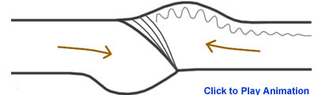
The Himalaya Mountain Range is the best active example of this type of plate boundary. The Himalaya Range where the Indian and Eurasian plates are currently in collision. The Appalachian Mountain Range is an ancient example of this collision type and is also marked on the map.
Effects found at a convergent boundary between continental plates include: a broad folded mountain range, shallow earthquake activity, shortening and thickening of the plates within the collision zone.

Transform Boundaries
A transform fault is formed when two plates slide past one another.
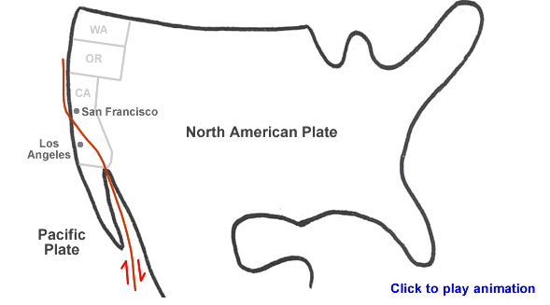
The most famous example of this is the San Andreas Fault Zone of western North America. Another example of a transform boundary on land is the Alpine Fault of New Zealand.
Transform faults are locations of recurring intense earthquake activity.

