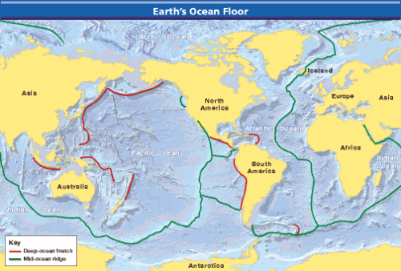
What is Sea Floor Spreading?

Mid-Ocean Ridges
In the mid-1900’s scientists mapped the ocean floor using a newly technology called sonar. Sonar is a device that bounces sound waves off underwater objects and then records the echoes of these sound waves. Harry Hess, an American geologist, was one of the scientists who first used sonar to discover mysterious underwater features which would come to be known as mid-ocean ridges.
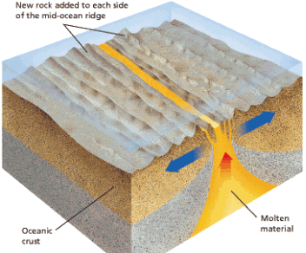
Mid-ocean ridges curve like the seam of a baseball along the sea floor. They extend into all of Earth’s oceans, Figure 1 shows the location of these ridges. Most of the mountains in the mid-ocean ridge system lie hidden under hundreds of meters of water. But in a few places the ridge pokes above the surface. For example, the island of Iceland is a part of the mid-ocean ridge that rises above the surface in the North Atlantic Ocean. The mapping of mid-ocean ridges made scientists curious to know more about them. What are the ridges? How do they form?
Figure 1: The mid-ocean ridge system is more than 50,000 kilometers long. Interpreting Maps What is unusual about Iceland?

Sea Floor Spreading
50 years earlier a young German scientist named Alfred Wegener (vay guh nur) had proposed the idea that continents can, and do, move but his idea was rejected since he had no explanation for how or why they moved. Hess carefully examined maps of the mid-ocean ridge system. Then he began to think about the ocean floor in relation to Alfred Wegener’s idea. Finally, he reached a startling conclusion: Maybe Wegener was right! Perhaps the continents do move!
Figure 2: Sea-Floor Spreading Molten material erupts through the valley that runs along the center of some mid-ocean ridges. This material hardens to form the rock of the ocean floor.
In 1960, Hess proposed a radical idea. He suggested that a process he called sea-floor spreading continually adds new material to the ocean floor. In sea-floor spreading, the sea floor spreads apart along both sides of a mid-ocean ridge as new crust is added. As a result, the ocean floors move like conveyor belts, carrying the continents along with them. Look at Figure 2 to see the process of sea-floor spreading.
Sea-floor spreading begins at a mid-ocean ridge, which forms along a valley/crack in the oceanic crust. Along the ridge, molten material several kilometers beneath the surface rises and erupts. At the same time, older rock is pushed outward on both sides of the ridge. As the molten material cools, it forms a new strip of solid rock. When even more molten material flows upwards it pushes this new strip outward on both directions. Sea floor spreading is driven by convection currents in the mantle.
Figure 3: Convection Currents in the Mantle drive sea-Floor Spreading.

Evidence of Sea Floor Spreading
Several types of evidence supported Hess’s theory of sea-floor spreading: eruptions of molten material, magnetic stripes in the rock of the ocean floor, and the ages of the rocks themselves. This evidence led scientists to look again at Wegener’s hypothesis again.

Evidence From Molten Material
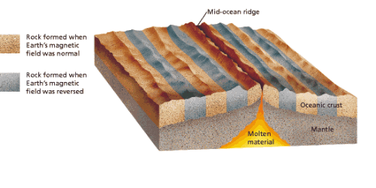
In the 1960s, scientists found evidence that new material is indeed erupting along mid-ocean ridges. The scientists dived to the ocean floor in Alvin, a small submarine built to withstand the crushing pressures four kilometers down in the ocean. In a ridge’s central valley, Alvin’s crew found strange rocks shaped like pillows or like toothpaste squeezed from a tube. Such rocks form only when molten material hardens quickly after erupting under water. These rocks showed that molten material has erupted again and again along the mid-ocean ridge.

Evidence from Magnetic Stripes
When scientists studied patterns in the rocks of the ocean floor, they found more support for sea-floor spreading. You read earlier that Earth behaves like a giant magnet, with a north pole and a south pole. Surprisingly, Earth’s magnetic poles have reversed themselves many times during Earth’s history. The last reversal happened 780,000 years ago. If the magnetic poles suddenly reversed themselves today, you would find that your compass needle points south.
Figure 4: Magnetic Stripes Magnetic stripes in the rock of the ocean floor show the direction of Earth’s magnetic field at the time the rock hardened. Interpreting Diagrams How are these matching stripes evidence of sea-floor spreading?
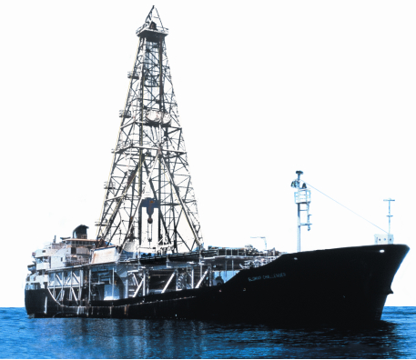
Scientists discovered that the rock that makes up the ocean floor lies in a pattern of magnetized “stripes.” These stripes hold a record of reversals in Earth’s magnetic field. The rock of the ocean floor contains iron. The rock began as molten material that cooled and hardened. As the rock cooled, the iron bits inside lined up in the direction of Earth’s magnetic poles. This locked the iron bits in place, giving the rocks a permanent “magnetic memory.”
Using sensitive instruments, scientists recorded the magnetic memory of rocks on both sides of a mid-ocean ridge. They found that stripes of rock that formed when Earth’s magnetic field pointed north alternate with stripes of rock that formed when the magnetic field pointed south. As shown in Figure 4, the pattern is the same on both sides of the ridge.

Evidence From Drilling Samples
The final proof of sea-floor spreading came from rock samples obtained by drilling into the ocean floor. The Glomar Challenger, a drilling ship built in 1968, gathered the samples. The Glomar Challenger sent drilling pipes through water six kilometers deep to drill holes in the ocean floor.
Figure 5: Sea-Floor Drilling The Glomar Challenger was the first research ship designed to drill samples of rock from the deep-ocean floor.
Samples from the sea floor were brought up through the pipes. Then the scientists determined the age of the rocks in the samples. They found that the farther away from a ridge the samples were taken, the older the rocks were. The youngest rocks were always in the center of the ridges. This showed that sea-floor spreading really has taken place.

