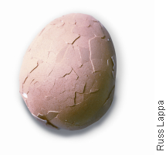**How do Earth’s Lithospheric Plates Work?**

Have you ever dropped a hard-boiled egg? If so, you may have noticed that the eggshell cracked in an irregular pattern of pieces. Earth’s lithosphere, its solid outer shell, is not one unbroken layer. It is more like that cracked eggshell. It’s broken into pieces separated by jagged cracks.

**Figure 1:** Earth’s lithosphere is broken into plates like a cracked egg shell.

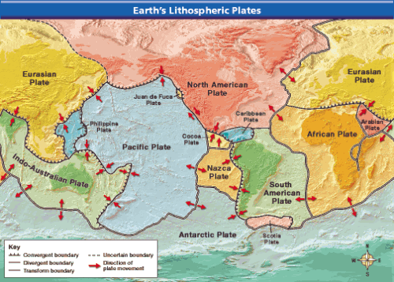A Canadian scientist, J. Tuzo Wilson, observed that there are cracks in the continents similar to those on the ocean floor. In 1965, Wilson proposed a new way of looking at these cracks. According to Wilson, the lithosphere is broken into separate sections called **[plates](javascript:openGlossaryWnd('e_gfplate')" \o "Glossary Term, link opens in new window).** The plates fit together along cracks in the lithosphere. As shown in Figure 2, the plates carry the continents or parts of the ocean floor, or both. Wilson combined what geologists knew about sea-floor spreading, Earth’s plates, and continental drift into a single theory. A **[scientific theory](javascript:openGlossaryWnd('e_gfscientificth')" \o "Glossary Term, link opens in new window)** is a well-tested concept that explains a wide range of observations.

What Causes Plates to Move?

**Figure 2:** Plate boundaries divide the lithosphere into large plates.

The theory of **[plate tectonics](javascript:openGlossaryWnd('e_gfplatetectoni')" \o "Glossary Term, link opens in new window)** (tek tahn iks) states that pieces of Earth’s lithosphere are in slow, constant motion, driven by convection currents in the mantle. **The theory of plate tectonics explains the formation, movement, and subduction of Earth’s plates.** During **subduction**, gravity pulls one edge of a plate down into the mantle. The rest of the plate also moves. As the plates move, they collide, pull apart, or grind past each other, producing spectacular changes in Earth’s surface. These changes include volcanoes, mountain ranges, and deep-ocean trenches.

Plate Boundaries.

The edges of Earth’s plates meet at plate boundaries. Plate boundaries extend deep into the lithosphere. **[Faults](javascript:openGlossaryWnd('e_gffault')" \o "Glossary Term, link opens in new window)**—breaks in Earth’s crust where rocks have slipped past each other—form along these boundaries. **As shown in**[**Figure 3**](javascript:openCrossRef('../ch1/ch1_s5_2.html%23view1_sx05_fart034L'))**, there are three kinds of plate boundaries: divergent boundaries, convergent boundaries, and transform boundaries. A different type of plate movement occurs along each type of boundary.**

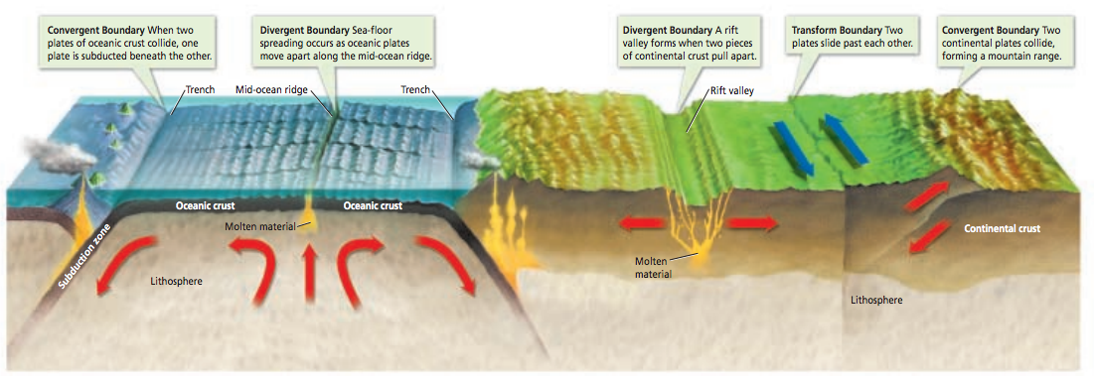

**Figure 3:**[Plate Tectonics](javascript:openPDF('view1_sx05_fart034.pdf')) Plate movements have built many of the features of Earth’s land surfaces and ocean floors.

Scientists have used instruments on satellites to measure plate motion very precisely. The plates move at amazingly slow rates: from about 1 to 24 centimeters per year. The North American and Eurasian plates are moving apart at a rate of 2.5 centimeters per year. That’s about as fast as your fingernails grow. This may not seem like much, but these plates have been moving apart for tens of millions of years.

## 

## Divergent Boundaries

The place where two plates move apart, or diverge, is called a **[divergent boundary](javascript:openGlossaryWnd('e_gfdivergentbou')" \o "Glossary Term, link opens in new window)** (dy vur junt)**.** Most divergent boundaries occur along the mid-ocean ridges where sea-floor spreading occurs, see figure 4:A. Divergent boundaries also occur on land. When a divergent boundary develops on land, two of Earth’s plates slide apart. A deep valley called a **[rift valley](javascript:openGlossaryWnd('e_gfriftvalley')" \o "Glossary Term, link opens in new window)** forms along the divergent boundary, see figure 4:B. For example, the Great Rift Valley in East Africa marks a deep crack in the African continent.

**Figure 4:** 2Types of divergent boundaries

## Convergent Boundaries

The place where two plates come together, or converge, is called a **[convergent boundary](javascript:openGlossaryWnd('e_gfconvergentbo')" \o "Glossary Term, link opens in new window)** (kun vur junt)**.** When two plates converge, the result is called a collision. When two plates collide, the density of the plates determines which one comes out on top.

Oceanic crust becomes cooler and denser as it spreads away from the mid-ocean ridge. Where two plates carrying oceanic crust meet at a trench, the plate that is more dense sinks under the other plate see figure 5:B. Sometimes a plate carrying oceanic crust collides with a plate carrying continental crust. Oceanic crust is more dense than continental crust. The less dense continental crust can’t sink under the more dense oceanic crust. Instead, subduction occurs as the oceanic plate sinks beneath the continental plate figure 5:A. When two plates carrying continental crust collide, subduction does not take place. Neither piece of crust is dense enough to sink very far into the mantle. Instead, the collision squeezes the crust into mighty mountain ranges figure 5:C.

**Figure 5:** 3Types of convergent boundaries

## ../../../../Desktop/Screen%20Shot%202016-11-07%20at%207.50.06%20PM.pn

## Transform Boundaries

A **[transform boundary](javascript:openGlossaryWnd('e_gftransformbou')" \o "Glossary Term, link opens in new window)** is a place where two plates slip past each other, moving in opposite directions figure 6. Earthquakes often occur along transform boundaries, but crust is neither created nor destroyed.

## Plate Motions Over Time

The movement of Earth’s plates has greatly changed Earth’s surface. Geologists have evidence that, before Pangaea existed, other supercontinents formed and split apart over billions of years. Pangaea itself formed when Earth’s landmasses drifted together about 260 million years ago. Then, about 225 million years ago, Pangaea began to break apart. 

**Figure 6:** 3Transform Boundary