MATTER
You have probably heard the word matter many times. Think about how often you hear the phrases “As a matter of fact,…” or “Hey, what’s the matter?” In science, this word has a specific meaning. Matter is anything that has mass and takes up space. All the “stuff” around you is matter, and you are matter too. Air, plastic, metal, wood, glass, paper, and cloth—all of these are matter.

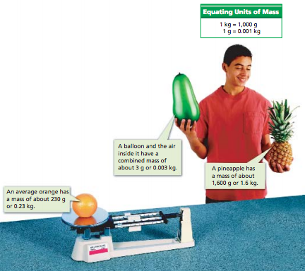
Mass
Why do you weigh less on the moon than on Earth? The force of gravity depends partly on the mass of an object. The mass of an object is the measurement of the amount of matter in the object. If you travel to the moon, the amount of matter in your body—your mass—does not change. But, the mass of the moon is much less than the mass of Earth, so the moon exerts much less gravitational force on you. Unlike weight, mass does not change with location, even when the force of gravity on an object changes. For this reason scientists prefer to measure matter by its mass rather than its weight. The mass of an object is a physical property.

Volume
You learned in Section 1 that all matter has mass and takes up space. The amount of space that matter occupies is called its volume. It’s easy to see that solids and liquids take up space. Gases have volume, too. Watch a balloon as you blow into it. You’re actually increasing the volume of gas in the balloon with your breath.

Units of Volume
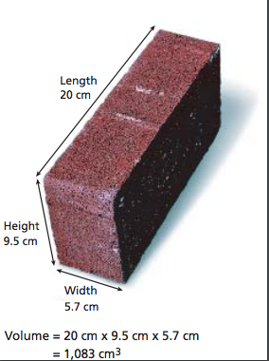
Common units of volume include the liter (L), milliliter (mL), and cubic centimeter (cm³). Some plastic soda bottles hold 1 liter of liquid. Volumes smaller than a liter are usually given in milliliters. A milliliter is one one-thousandth of a liter and is exactly the same volume as 1 cubic centimeter. A teaspoonful of water has a volume of about 5 milliliters, and an ordinary can of soda contains 355 milliliters of liquid. In the laboratory, volumes of liquid are usually measured with a graduated cylinder.

Calculating Volume
The volumes of solid objects are usually expressed in cubic centimeters. Suppose you want to know the volume of a rectangular object, such as the brick shown in Figure 13. First, you measure the brick’s length, width, and height (or thickness). Then, you multiply these values.
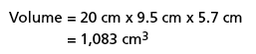
Figure 1: Finding Volume The volume of a regular solid can be found by measuring its dimensions and multiplying the values.

Measurements always have units. So, when you multiply the three measurements, you must multiply the units as well as the numbers.

Density
Samples of two different materials may have the same volume, but they don’t necessarily have the same mass. Remember the riddle about the sand and the feathers? A kilogram of sand takes up much less space than a kilogram of feathers. The volumes differ because sand and feathers have different densities—an important property of matter. Density relates the mass of a material in a given volume. Often, density is expressed as the number of grams in one cubic centimeter. For example, the density of water at room temperature is stated as “one gram per cubic centimeter (1 g/cm³).” This value means that every gram of water has a volume of 1 cm³. Notice that the word per is replaced by the fraction bar in the units of density. The bar tells you that you can determine the density of a sample of matter by dividing its mass by its volume.

Sinking or Floating?
Suppose you have a solid block of wood and a solid block of iron. When you drop both blocks into a tub of water, you can see right away that the wood floats and the iron sinks. You know the density of water is 1 g/cm³. Objects with densities greater than that of water will sink. Objects with lesser densities will float. So, the density of this wood is less than 1 g/cm³. The density of the iron is greater than 1 g/cm³.
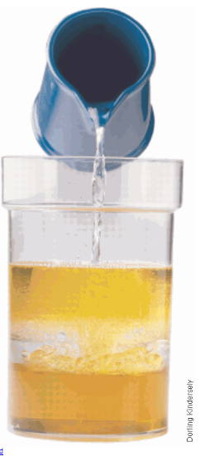
Watch a bottle of oil-and-vinegar salad dressing after it has been shaken. You will see oil droplets rising above the vinegar. Finally, the oil forms a separate layer above the vinegar. What can you conclude? You’re right if you said that the oil is less dense than vinegar.

Using Density
Density is a physical property of a substance. So, density can be used to identify an unknown substance. For example, suppose you were hiking in the mountains and found a shiny, golden-colored rock. How would you know if the rock was really gold? Later at home, you could look up the density of gold at room temperature. Then measure the mass and volume of the rock and find its density. If the two densities match, you would have quite a find! 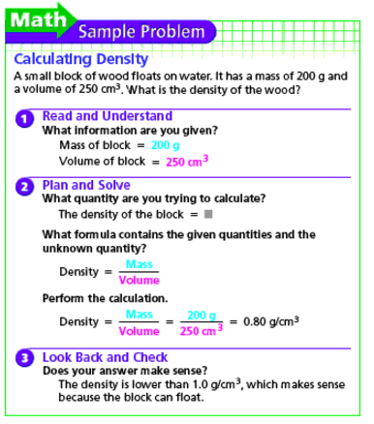
Figure 2: Density Layers The density of water is less than corn syrup but greater than vegetable oil.

