Exploring Inside Earth
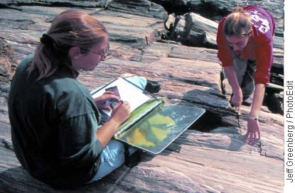
Earth’s surface is constantly changing. Throughout our planet’s long history, its surface has been lifted up, pushed down, bent, and broken. Thus Earth looks different today from the way it did millions of years ago.
Volcanic eruptions like those at Mount Kilauea make people wonder, What’s inside Earth? Yet this question is very difficult to answer. Much as geologists would like to, they cannot dig a hole to the center of Earth. The extreme conditions in Earth’s interior prevent exploration far below the surface.
Figure 2: Getting Beneath the Surface Geologists examine rocks for clues about what’s inside Earth. Even though caves like this one in Georgia (bottom photo) may seem deep, they reach only a relatively short distance beneath the surface.

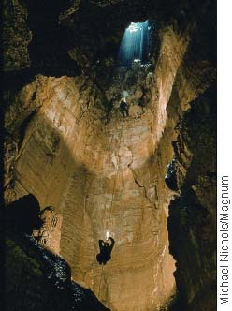
The deepest mine in the world, a gold mine in South Africa, reaches a depth of 3.8 kilometers. But that mine only scratches the surface. You would have to travel more than 1,600 times that distance—over 6,000 kilometers—to reach Earth’s center. Geologists have used two main types of evidence to learn about Earth’s interior: direct evidence from rock samples and indirect evidence from seismic waves. The geologists in Figure 2 are observing rock on Earth’s surface.

Direct Evidence from Rock Samples
Rocks from inside Earth give geologists clues about Earth’s structure. Geologists have drilled holes as much as 12 kilometers into Earth. The drills bring up samples of rock. From these samples, geologists can make inferences about conditions deep inside Earth, where these rocks formed. In addition, forces inside Earth sometimes blast rock to the surface from depths of more than 100 kilometers. These rocks provide more information about the interior.

Indirect Evidence from Seismic Waves
Geologists cannot look inside Earth. Instead, they must rely on indirect methods of observation. Have you ever hung a heavy picture on a wall? If you have, you know that you can knock on the wall to locate the wooden beam underneath the plaster that will support the picture. When you knock on the wall, you listen carefully for a change in the sound.
To study Earth’s interior, geologists also use an indirect method. But instead of knocking on walls, they use seismic waves. When earthquakes occur, they produce seismic waves (syz mik). Geologists record the seismic waves and study how they travel through Earth. The speed of seismic waves and the paths they take reveal the structure of the planet.
Using data from seismic waves, geologists have learned that Earth’s interior is made up of several layers. Each layer surrounds the layers beneath it, much like the layers of an onion. In Figure 3, you can see how seismic waves travel through the layers that make up Earth.
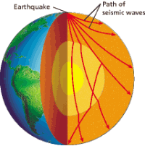
Figure 3: Seismic Waves Scientists infer Earth’s inner structure by recording and studying

